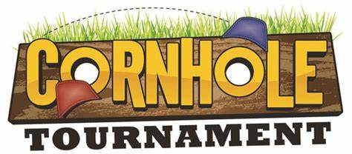

**WHEN**

October 12th

Starts at Noon

**WHERE**

Audubon Park Community Hall

20 Road C

Audubon Park, NJ 08106

**FEATURING**

Cash Prize for 1st, 2nd and 3rd Place

Food and Beer Provided

50/50

Music

Trophy for the Winner

**CASH PAYOUT**

1ST PLACE - $500

2ND PLACE - $300

3RD PLACE - $100

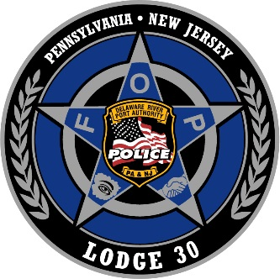

**ENTRY FEE**

$80 per team by **October 1st**

2 Players per team

$25 for Spectator (Includes Food and Beer)

*CASH CHECK OR*

*VENMO @militoscholarship*

**STRUCTURE & RULES**

[ACL Rules](https://mysqlvm.blob.core.windows.net/acl-docs/ACL-Rules-Regs-2018-2019.pdf)

Double Elimination

Brackets will be drawn randomly prior to the event

**BENEFITING**

*Cpl. Christopher Milito*

*Scholarship Fund*

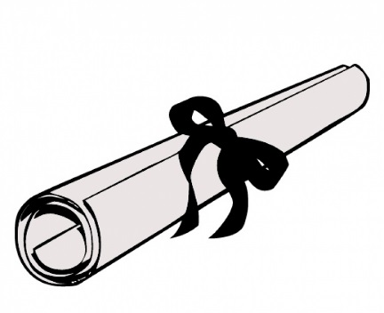

**Contact:**

**John Hogan**

(856) 889-7655

**Jessica Gabe**

(610) 389-5785

**Jay Keefer**

(856) 207-9015