FOP LODGE 30 FUNDRAISER
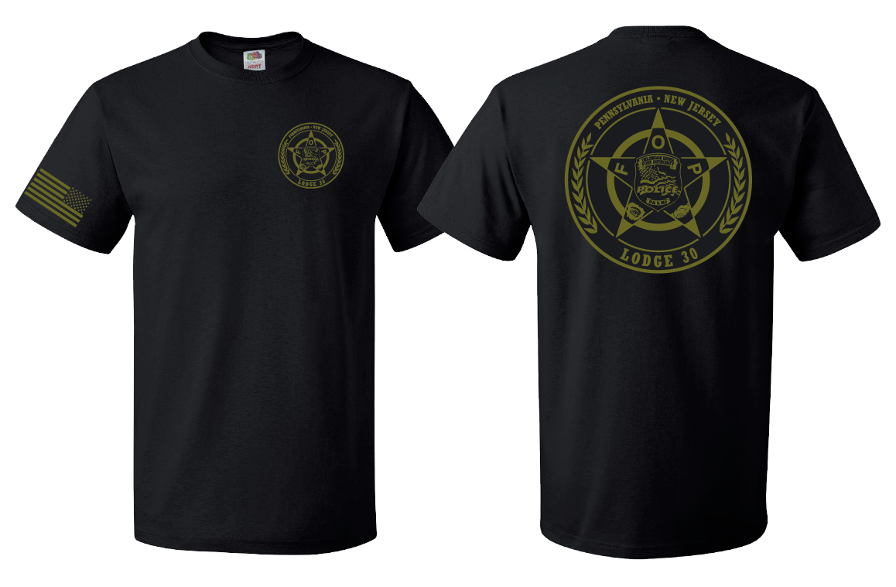
Available Styles & Sizes
Short Sleeve - Small-5XL: $15
Long Sleeve – Small-5XL: $20
Pullover Hoodie – Small-5XL: $25

Contact a member of FOP Lodge 30 if you would like to purchase a shirt or sweatshirt.

** The funds raised go to support the Lodge’s Christmas Toy Drive in December. The regular t-shirts are Gildan 50/50 blend. The pullover sweatshirts are Gildan 40/60 cotton/polyester blend. **

